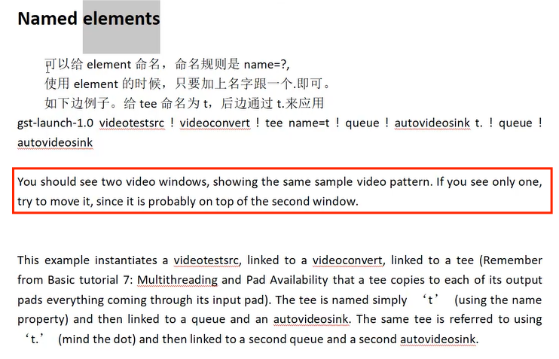

gst-launch-1.0 videotestsrc ! videoconvert ! tee name=t ! queue ! autovideosink t. ! queue ! autovideosink